**C&L (Communication and Language)**

*Core Texts: ‘****Tyrannosaurus Drip’****,* ***‘Rainbowsaurus’, ‘Never ask a Dinosaur to Dinner’*** *and* ***‘Cave Baby’***

* Daily story time
* Practise listening attentively and respond to what they hear with relevant comments
* Encourage speaking in full sentences using the correct tense.
* Talk about different characters in stories and make simple predictions
* Talk about why they are special
* Talk about themselves and their families during play or news time
* Role play stories using puppets and or costumes and props
* Ask and answering questions in Plan Do Review time

**PSED (Personal, Social and Emotional Development)**

* Daily ‘Special Person’ linked to our Christian values **Friendship, Respect, Thankfulness, Truth and Forgiveness**
* Snack times / daily circle times
* Prayer times
* PSHE stories, songs and videos
* Independence in toileting, handwashing, changing wellies, fastening own coats and taking responsibility for their belongings
* Following the Corbridge School Calm Code
* Daily peer massage

**EYFS Curriculum**

**Dinosaurs**

**Spring 1 2025**

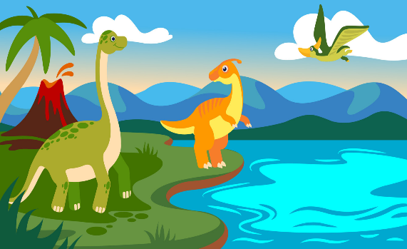

**Don’t forget …**

**To stay in school:**

* A spare change of clothes
* Wellies
* PE kit

**To bring in everyday**:

* A named water bottle
* A warm coat
* Bookbag with reading book and green sounds book

Make sure everything is **LABELLED**!

* Tell us about any special activities your child has been up to on TAPESTRY and we will share them during news time.
* Check your parentmail account regularly
* Visit our school website for further information [www.corbridgefirst.northumberland.sch.uk](http://www.corbridgefirst.northumberland.sch.uk)
* We will also tweet on Twitter - @CorbridgeFirst

**PD (Physical Development)**

**Gross Motor**

* Daily outside play on large equipment
* Bikes, scooters and ride on toys
* Weekly PE Lessons with Mr Thompson
* Dinosaur footprint obstacle course

**Fine Motor:**

* Play-dough, threading, lego, puzzles, using tweezers, pegs etc
* Use a range of tools confidently and safely e.g. scissors, paint brushes, glue spreaders, pencils, knives, forks and spoons
* Form most of the letters in the alphabet correctly

**UW (Understanding the World)**

* Christian values/ prayers
* Weekly Jack in the Box worship
* Weekly RE lessons: ‘Where do we belong?’
* Weekly Forest School lessons
* Seasonal changes
* Explore processes and changes such as investigating ice melting
* Understand the past through settings, characters and events in dinosaur books
* STEM fortnight

**Literacy**

*Core Texts: ‘****Tyrannosaurus Drip’****,* ***‘Rainbowsaurus’ ‘Saturday Night at the Dinosaur Stomp’,*** *and* ***‘Cave Baby’***

* Weekly small group reading
* Daily adult directed tasks to encourage writing for a purpose and using reading skills
* Daily Read Write Inc. phonics lessons
* To read words through Fred talk e.g. h-a-t, p-o-t, th-i-s
* To write words using the sounds they have learnt
* To recognise some red tricky words e.g. I, my, the, you, are, of, said and begin to use them in their writing
* Writing opportunities in provision e.g. pencils, chalk, felt tips, tracing paper, post-it notes, role play writing, handwriting patterns

**Mathematics**

Following **White Rose Maths**, we will cover the topics in our daily group sessions:

* Alive in 5
* Mass and Capacity
* 6,7,8

Dinosaur themed maths activities such as measuring with dinosaur footprints.

Other daily maths opportunities:

* Share date, visual timetable, and number of children daily.
* Daily counting forwards and backwards
* Daily number songs and rhymes
* Measuring out playdough or cooking ingredients
* In provision: counting objects, maths games and puzzles, timers, 2D/3D shapes, dominoes, measuring equipment, Numicon

**Expressive arts and design**

* Explore colour mixing, shape and texture to make dinosaur pictures
* Use scissors to cut straight and curved edges
* Weekly music session with Mr Reed
* Develop imaginary and pretend play in dinosaur themed role play
* Design and make a dinosaur small world scene
* Create a dinosaur menu in the mud kitchen
* Dinosaur footprints in different materials e.g. paint, clay
* Junk modelling
* Sing and move to dinosaur songs and rhymes

**Help at home by …**

* Support your child with their **Reading Book** at home and writing in their reading diary three times a week.
* Practise reading and writing sounds from their **Green Sound Book** they have learnt in a variety of contexts e.g. with pens, chalk, in sand, outdoor materials, magnetic letters. Can they read a write CVC words using the sounds they have learnt?
* Encourage everyday **Maths –** measuring when baking/cooking, playing board games/dominoes, sorting objects, sharing out items, using money, shape and number hunts.