|  |  |  |  |  |  |  |  |  |
| --- | --- | --- | --- | --- | --- | --- | --- | --- |
| **Autumn 1** | | **Autumn 2** | | **Spring 1** | **Spring 2** | **Summer 1** | | **Summer 2** |
| **Y**  **E**  **A**  **R**  **1** | **Me and My School**  **Knowledge: know the layout of our school grounds**  **Recognise N/S/E/W on a compass**  **Understand some symbols on a map and what they represent**  **Concepts: Location and Place**  **Skills: mapping skills and knowledge of direction**  **NC Geographical Skills & Fieldwork**   * use simple compass directions (north, south, east and west) and locational and directional language [for example, near and far, left and right], to describe the location of features and routes on a map * use simple fieldwork and observational skills to study the geography of their school and its grounds and the key human and physical features of its surrounding environment | | **Our Local Area**  **Knowledge: know our school is in Corbridge.**  **Discuss why people settled here and what can be found in and around our village**  **Recognise N/S/E/W on a compass**  **Understand some symbols on a map and what they represent**  **Concepts: Location and Place**  **Planning and Decision Making**  **Skills: Using simple maps.**  **Introducing fieldwork/enquiry**  **NC Human & Physical Geography**   * use basic geographical vocabulary to refer to key human features, including: city, town, village, factory, farm, house, office, port, harbour and shop   **NC Geographical Skills & Fieldwork**   * use aerial photographs and plan perspectives to recognise landmarks and basic human and physical features; devise a simple map; and use and construct basic symbols in a key * use simple fieldwork and observational skills to study the geography of their school and its grounds and the key human and physical features of its surrounding environment | | | | **Seaside Locations**  **Knowledge: Key features of seaside locations**  **Concepts: Location and Place, Cause and Effect**  **Planning and decision making**  **Skills: Using an atlas, reading maps and photographs.**  **NC Locational Knowledge**   * name, locate and identify characteristics of the 4 countries and capital cities of the United Kingdom and its surrounding seas   **NC Human & Physical Geography**   * use basic geographical vocabulary to refer to key physical features, including: beach, cliff, coast, forest, hill, mountain, sea, ocean, river, soil, valley, vegetation, season and weather   **NC Geographical Skills & Fieldwork**   * use aerial photographs and plan perspectives to recognise landmarks and basic human and physical features; devise a simple map; and use and construct basic symbols in a key * use world maps, atlases and globes to identify the United Kingdom and its countries, as well as the countries, continents and oceans studied at this key stage * use simple compass directions (north, south, east and west) and locational and directional language [for example, near and far, left and right], to describe location of features and routes on a map | |
| **Y**  **E**  **A**  **R**  **2** | **Mapping skills**  **Weather Patterns**  **Knowledge: Recognise seasonal and daily weather patterns**  **Concepts: Location and Place, Scale**  **Skills: mapping skills and direction**  **NC Human & Physical Geography**   * Identify seasonal and daily weather patterns in the United Kingdom and the location of hot and cold areas of the world in relation to the Equator and the North and South Poles | | **Around the World**  **Knowledge: Know the countries of the UK and their capital cities.**  **Know characteristics of these countries.**  **Concepts: Location and Place**  **Skills: Observations, using maps, reading photographs**  **NC Locational Knowledge**   * Name and locate the world’s 7 continents and 5 oceans * Name, locate and identify characteristics of the 4 countries and capital cities of the United Kingdom and its surrounding seas   **Our Country**  **Knowledge: Know the countries of the UK and their capital cities.**  **Know characteristics of these countries.**  **Concepts: Location and Place**  **Skills: Observations, using maps, reading photographs**  **NC Geographical Skills & Fieldwork**   * Use world maps, atlases and globes to identify the United Kingdom and its countries, as well as the countries, continents and oceans studied at this key stage * Use simple compass directions (north, south, east and west) and locational and directional language [for example, near and far, left and right], to describe the location of features and routes on a map | | | | **Let’s go to… Kenya/China**  **(Contrasting non-European country)**  **Knowledge: country specific knowledge**  **Comparing our local environment with a contrasting country**  **Names of oceans and continents**  **Concepts: Location and Place, Systems and Processes**  **Skills: Using an atlas, reading maps and reading photographs. Using observation and videos**  **NC Locational Knowledge**   * Name and locate the world’s 7 continents and 5 oceans   **NC Place Knowledge**   * Understand geographical similarities and differences through studying the human and physical geography of a small area of the United Kingdom, and of a small area in a contrasting non-European country   **NC Geographical Skills & Fieldwork**   * Use world maps, atlases and globes to identify the United Kingdom and its countries, as well as the countries, continents and oceans studied at this key stage | |

**Whole School Curriculum Design: Geography Sequence of Learning & Progression of Skills EYFS & KS1**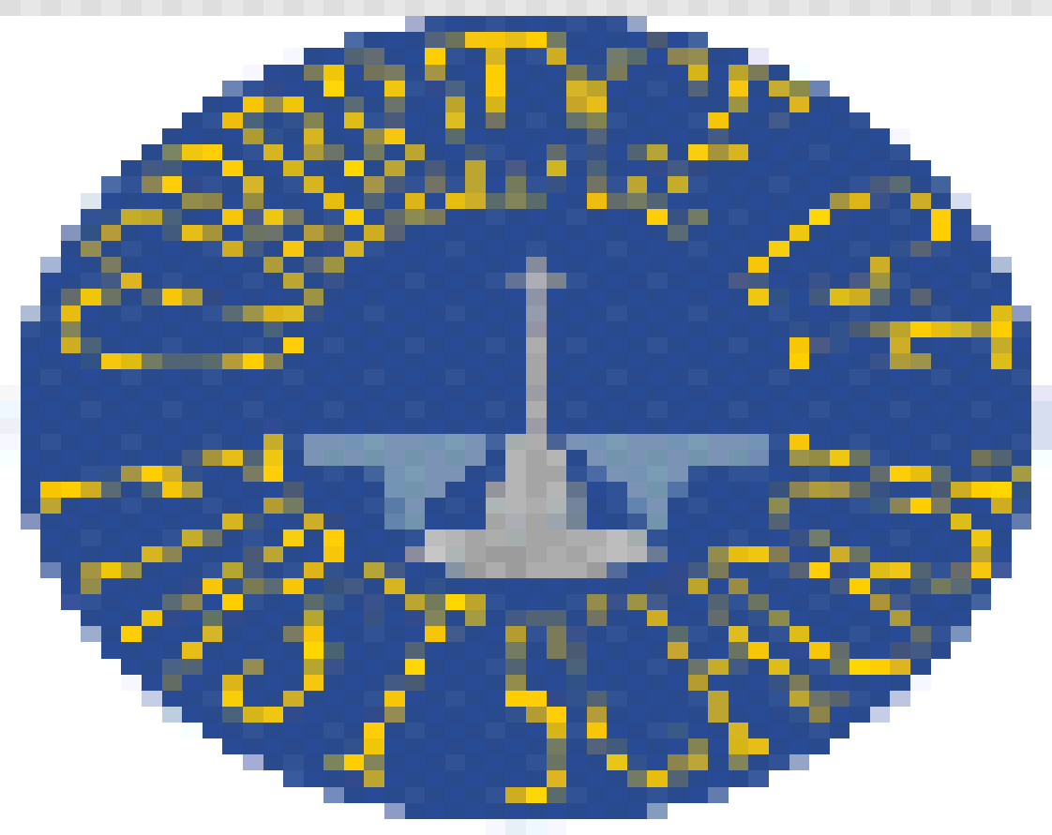

|  |  |  |  |
| --- | --- | --- | --- |
|  | **Autumn** | **Spring** | **Summer** |
| **YEAR 3** | **Water – From Clouds to Coast**  **Knowledge: The Water Cycle, Introduction to Rivers**  **Concepts: Cause and Effect, Location and Place, systems and processes**  **Skills: Maps and diagrams, ask geographical questions, record findings, fieldwork and enquiry**  **NC Human and Physical Geography**  Describe and understand key aspects of:   * Physical geography, including the water cycle * Human geography, including the distribution of natural resources including water   **NC Geographical Skills & Fieldwork**   * Use maps, atlases, globes and digital/computer mapping to locate countries and describe features studied * Use fieldwork to observe, measure record and present the human and physical features in the local area using a range of methods, including sketch maps, plans and graphs, and digital technologies | **Rainforests – The Lungs of the Earth**  **Knowledge: Equator, North Pole, South Pole, Climate Zones, Biomes.**  **Significance of the Tropics. Longitude and Latitude.**  **Deforestation, Protecting the Rainforests**  **Concepts: Cause and Effect, Location and Place, Change, Inequality**  **Skills: Using an atlas, reading maps, reading photographs, digital & satellite images, numerical data, enquiry, mapping skills**  **NC Human and Physical Geography**  Describe and understand key aspects of:   * physical geography, including: climate zones, biomes and vegetation belts, rivers and the water cycle   **NC Locational Knowledge**   * Identify the position and significance of latitude, longitude, Equator, Northern Hemisphere, Southern Hemisphere, the Tropics of Cancer and Capricorn, Arctic and Antarctic Circle, the Prime/Greenwich Meridian and time zones (including day and night)   **NC Geographical Skills & Fieldwork**   * Use maps, atlases, globes and digital/computer mapping to locate countries and describe features studied |  |
| **YEAR 4** | **Geography of Modern Greece**  **Knowledge: Europe’s climate**  **Vegetation belts**  **Tourism case study**  **Concepts: Location and place knowledge, cause and effect, change over time**  **Skills: Using an atlas, reading maps, reading photographs, ask Geographical questions, record findings, identify position**  **NC Locational Knowledge**   * Locate the world’s countries, using maps to focus on Europe   **NC Human and Physical Geography**   * Describe and understand key aspects of: physical geography, including: climate zones, biomes and vegetation belts * Human geography, including: types of settlement and land use, economic activity including trade links, and the distribution of natural resources including energy, food, minerals and water   **NC Geographical Skills & Fieldwork**   * Use maps, atlases, globes and digital/computer mapping to locate countries and describe features studied * Use photographs, temperature data and graphs to find information. | **The River Tyne**  **Locational knowledge and map skills**  **Knowledge:**  **The water cycle, continents and oceans, rivers from source to mouth.**  **Topographical features**  **Land forms, meanders and ox-bow lakes**  ***Revisit Amazon river learning and water cycle***  **Concepts: Locational knowledge and map skills, Physical Geography, Change**  **Skills: Maps and diagrams, fieldwork and enquiry, aerial photos and photograph analysis, analysing weather data.**  **NC Human and Physical Geography**   * Describe and understand key aspects of: physical geography, including: climate zones, biomes and vegetation belts, rivers, mountains, volcanoes and earthquakes, and the water cycle   **NC Geographical Skills & Fieldwork**   * Use maps, atlases, globes and digital/computer mapping to locate countries and describe features studied * Use fieldwork to observe, measure, record and present the human and physical features in the local area using a range of methods, including sketch maps, plans and graphs, and digital technologies   **Somewhere to Settle –**  **What is special about the North East?**  **Knowledge: The North East as a geographical location: coastal areas,**  **rivers, valleys, hills**  **Concepts:, Location and Place, Systems & Processes**  **Skills: Fieldwork and map work, evaluating location, making decisions**  **NC Human and Physical Geography**  Describe and understand key aspects of:   * Human geography, including: types of settlement and land use, economic activity including trade links, and the distribution of natural resources including energy, food, minerals and water   **NC Geographical Skills & Fieldwork**   * Use maps, atlases, globes and digital/computer mapping to locate countries and describe features studied * Use the 8 points of a compass, 4- and 6-figure grid references, symbols and key (including the use of Ordnance Survey maps) to build their knowledge of the United Kingdom and the wider world * use fieldwork to observe, measure record and present the human and physical features in the local area using a range of methods, including sketch maps, plans and graphs, and digital technologies |  |



|  |  |  |  |  |  |  |
| --- | --- | --- | --- | --- | --- | --- |
| **EYFS** | | **Knowledge: Know that we live on a planet called Earth that is made up of land and sea.**  **Know there is a sun, moon and planets.**  **Know where they live.**  **Concepts: A Sense of Place**  **Skills: talk about features of our environment and how environments may differ.**  **Know about similarities and differences in relation to places.**  **Show concern for the environment.**  **Comment and ask question about aspects of their familiar world.**  **Knowledge: Know that there are different people helping me to do different jobs**  **Concepts: A Sense of Place**  **Skills: show an interest in and talk about different jobs people do** | | | **ELG 13 People & Communities**  Children talk about past and present events in their own lives and in the lives of family members. They know that other children don’t always enjoy the same things, and are sensitive to this. They know about similarities and differences between themselves and others, and among families, communities and traditions.  **ELG 14 Understanding the World**  to know about similarities and differences in relation to places, objects, materials and living things.  to talk about the features of their own immediate environment and how environments might vary from one another.  to make observations of animals and plants and explain why some things occur, and talk about changes. | |
| **Further Opportunities for Geography Enrichment at Corbridge:**   * Community Projects – pond regeneration, park, use of school grounds for play equipment * **Global Goal Keepers – Pupil Voice** * **School Eco Council** * Recycling project * Sustainable development * **School allotment** * Tree Planting – Woodland Trust * Eco Gold award for planting * Links with local businesses – sustainability – Osbit * RMOPS * **Commando Joe’s** | | | **Core Concepts covered within Geography Lessons:**  **Planning and Decision Making:**  Exploring the different options when making decisions. Considering the changing characteristics of an environment and/or location.  **Change:**  Developing an understanding about natural causes of change and inequality. Considering change as a direct result of human impact.  **Location and Place:**  Understanding WHY and HOW people and places can be affected by a range of locational factors e.g. culture, climate, political.  **Cause and Effect:**  Understanding that different causes have different levels of significance and effect.  **Inequality:**  A specific form of cause and effect.  **Systems & Processes:**  Geographical systems and processes e.g. the water cycle | | | |
| **Geography Big Questions:** | | | | | | |
| **Partnership Learning: Middle School UKS2 Curriculum Coverage** | | | | | | |
| **YEAR 5 CMS** | **Locational Knowledge**  **United Kingdom - Counties, Cities & Trade** | | | **Locational Knowledge**  **World’s Countries – continents, countries, population, Mountains & Rivers** | | **Modern Egypt**  **Population & comparisons with UK** |
| **YEAR 6 CMS** | **Human & Physical Geography**  **Extreme Earth – Volcanoes, Tsunamis & drought (water cycle)** | | | **Human & Physical Geography**  **Rivers – Local study of the Tyne & flooding** | | **South America**  **Countries, culture, climate & industries & compare with UK** |

